Mickelson Middle School Math Department
October 2013

Top 5 Big Ideas to help your child with Digits
- Explore the website and the possibilities that are within the program itself with your child. You can’t break the program, so please explore.
- Use the links on the side of the homework assignments.
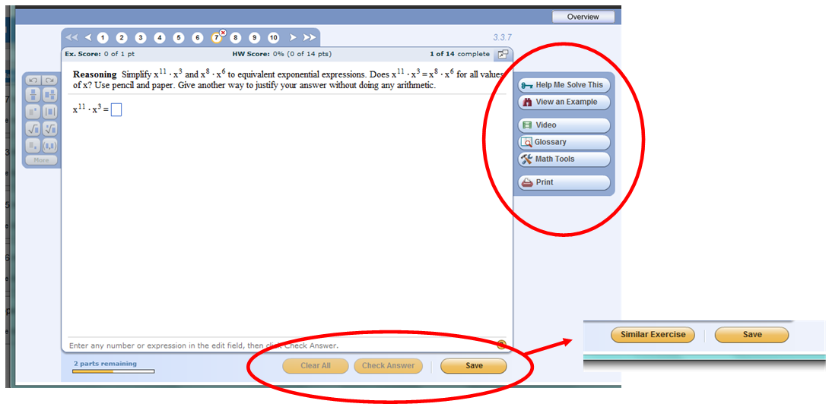
Help Me Solve This | This button takes your child through a step-by-step tutorial where he/she fills in the blanks in order to solve this problem. The computer will then generate new numbers for the problem he/she will have to complete for the assignment.
View an Example | Your child can view an example of a similar problem worked out entirely.
Video | Some questions have videos where another teacher re-teaches the same topic needed to solve this problem.
Glossary | Your child can look up any math vocabulary that he/she does not understand.
Math Tools | This button takes you to a selection of online math tools and manipulatives that may help your child solve this problem. (See Big Idea #3 below)
Check/Submission Buttons  (bottom bar) | If your child does not answer a question correctly, the buttons on the bottom will change so that they are able to try again if he/she clicks the “Similar Exercise” button.

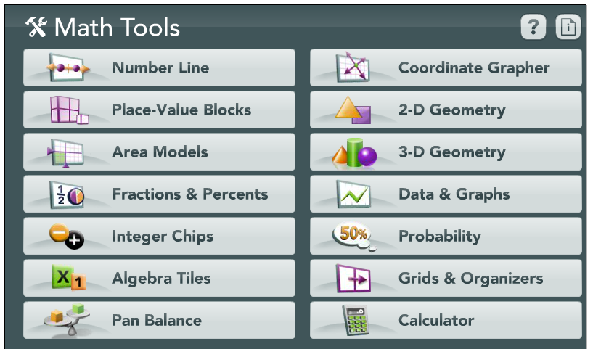
- Use the math tools to gain access to digital manipulatives.

On the right side of the homework is a button for Math Tools. Once you have clicked on the link, the window to the right appears. Once you click on each topic there are subsections you may use for homework help. During the lessons from time to time there will be a video tutorial to use each part of the math tools. However, there is no substitute for being able to explore. You will not break anything by playing. Feel free to use these tools whenever possible.
- Be aware of the available tools from the dashboard (the initial page you see). From here you are able to re-watch a lesson, see old assignments, and complete your homework.
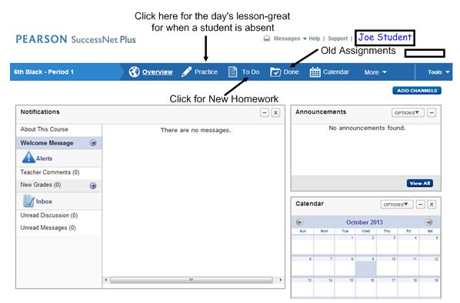

- We recommend using Google Chrome for a web browser. This is a free download and does not take much effort. Internet Explorer and Firefox will work, but we feel that Google Chrome is the best option, followed by the other two respectively.

